**SD Bus Protocol**

**3.0.1 SD Bus**

Communication over the SD bus is based on command and data bit streams that are initiated by a start bit and terminated by a stop bit.

* Command: a command is a token that starts an operation. A command is sent from the host either to a single card (addressed command) or to all connected cards (broadcast command). A command is transferred serially on the CMD line.
* Response: this is a token sent from an addressed card, or (synchronously) from all connected cards, to the hosts as an answer to a previously received command. A response is transferred serially on the CMD line.
* Data: data can be transferred from the card to the host or vice versa. Data is transferred via the data lines.

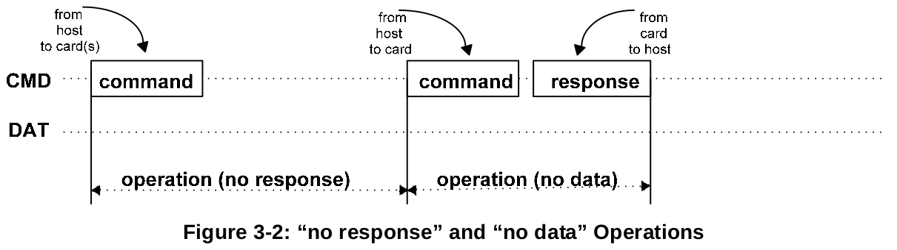

Card addressing is implemented using a session address, assigned to the card during the initialization phase.

Data transfer to/from the SD Memory Card are done in blocks. Data blocks are always succeeded by CRC bits. Single and multiple block operations are defined. Note that the Multiple Block operation mode is better for faster write operation. A multiple block transmission is terminated when a stop command follows on the CMD line. Data transfer can be configured by the host to use single or multiple data lines.

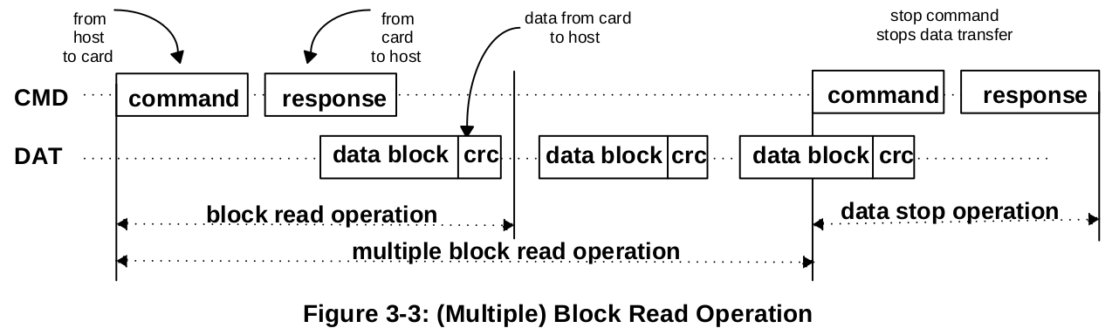

The block write operation uses a simple busy signalling of the write operation duration on the DAT0 data line regardless of the number of data lines used for transferring the data.

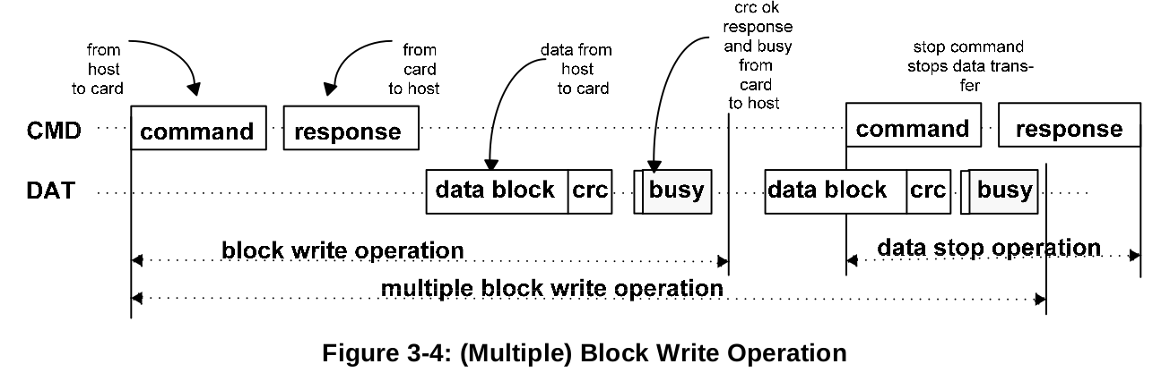

Command tokens have the following coding scheme:

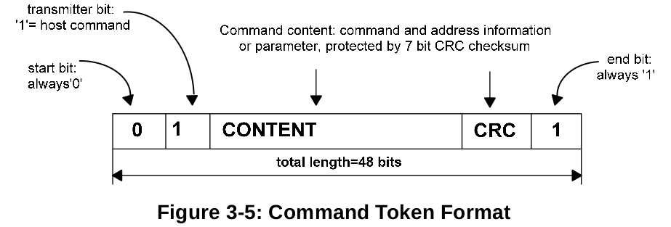

Each command token is preceded by a **start bit (0)** and succeeded by an **end bit (1)**. The total length is 48 bits. Each token is protected by CRC bits so that transmission errors can be detected and the operation may be repeated.

Response tokens have one of four coding schemes, depending on their content. The token length is either 48 or 136 bits. The CRC protection algorithm for block data is a 16-bit CCITT polynomial.

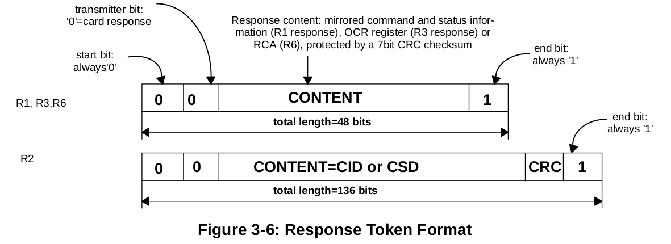

In the CMD line the Most Significant Bit (MSB) is transmitted first, the Least Significant Bit (LSB) is last. When the wide bus option is used, the data is transferred 4 bits at a time. Start and end bits, as well as the CRC bits, are transmitted for every one of the DAT lines. CRC bits are calculated and checked for every DAT line individually. The CRC status response and Busy indication will be sent by the card to the host on DAT0 only.

There are two types of Data packet format for the SD card:

1. Usual data (8-bit width): The usual data (8-bt width) is sent LSB first, MSB last. But in the individual byte, it is MSB first, LSB last.
2. Wide width data (SD Memory Register): The wide width data is shifted from the MSB bit.

**Data Packet Format for Usual Data (8-bit width)**

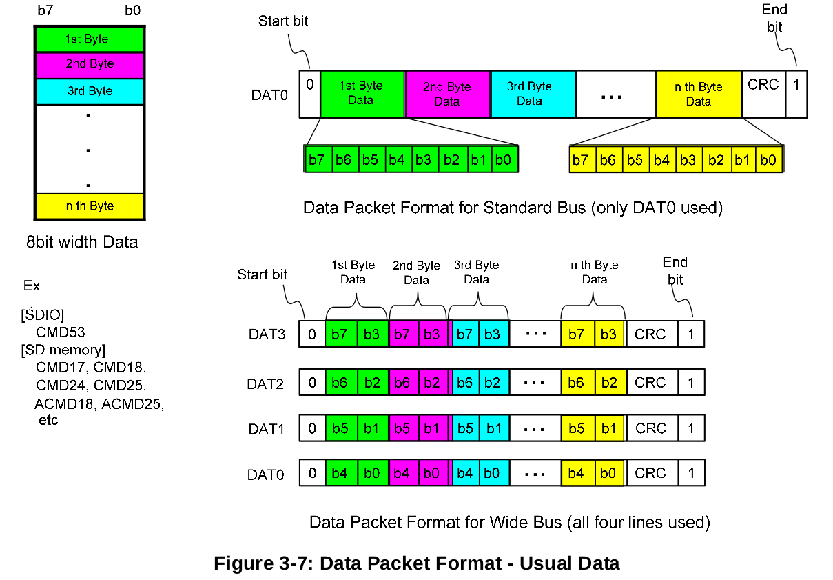

**Data Packet Format for Wide Width Data (Ex. ACMD13)**

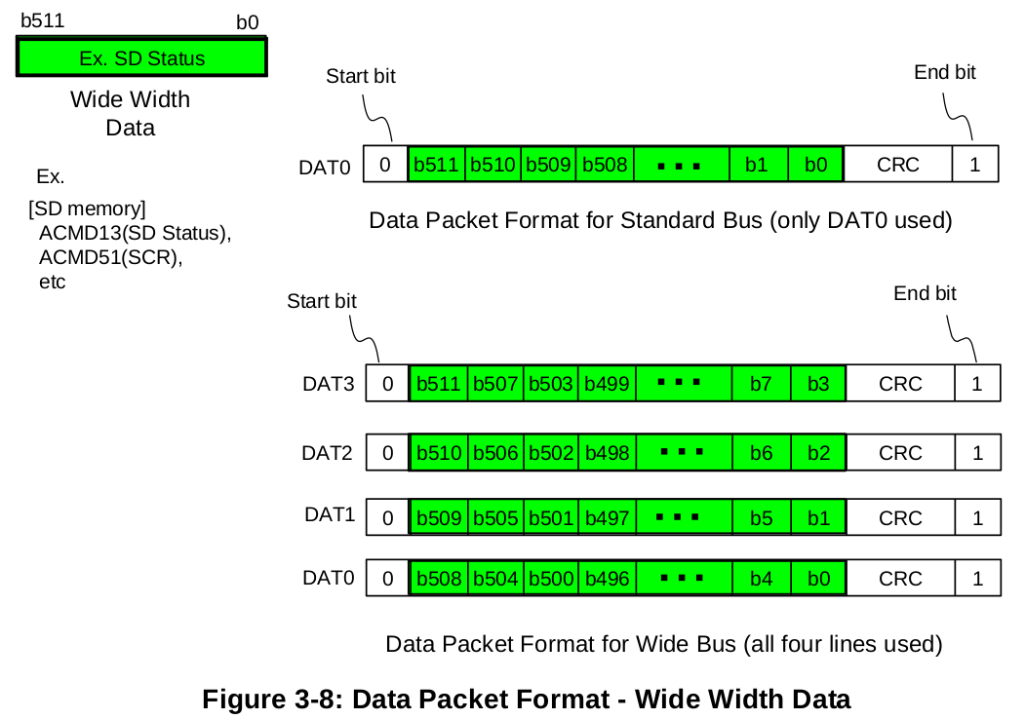

**3.1 SD Memory Card Functional Description**

All communication between host and cards is controlled by the host (master). The host send commands of two types: broadcast and addressed(point-to-point) commands.

**Broadcast commands**

Broadcast commands are intended for all cards. Some of these commands require a response.

**Addressed(point-to-point) commands**

The addressed commands are sent to the addressed card and cause a response from this card.

**Card identification mode**

The host will be in card identification mode after reset and while it is looking for new cards on the bus. Cards will be in this mode after reset until the SENDRCA command (CMD3) is received.

**Data transfer mode**

Cards will enter data transfer mode after their RCA is first published. The host will enter data transfer mode after identifying all the cards on the bus.

The following table shows the dependencies between operation modes and card states.

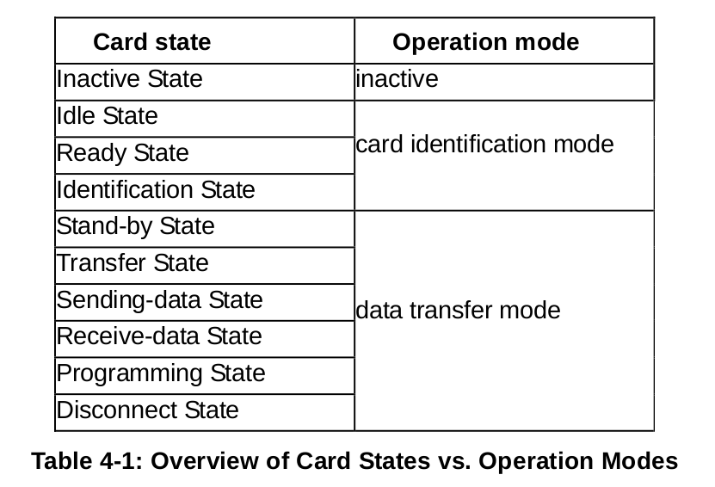

**3.2 Card Identification Mode**

While in card identification mode the host resets all the cards that are in card identification mode, validates operation voltage range, identifies cards and asks them to publish Relative Card Address (RCA). This operation is done to each card separately on its own CMD line. All data communication in the Card Identification Mode uses the Command line (CMD) only. During the card identification process, the card shall operate in the SD clock frequency of the identification clock rate.

**3.2.1 Card Reset**

The command GOIDLESTATE (CMD0) is the software reset command and sets each card into *Idle State* regardless of the current card state.

**3.2.2 Operating Condition Validation**

The host issues a reset command (CMD0) with a specified voltage while assuming it may be supported by the card. To verify the voltage, a following new command (CMD8) is defined in the Physical Layer Specification Version 2.00.

SENDIFCOND (CMD8) is used to verify SD Memory Card interface operating condition. The card checks the validity of operating condition by analysing the argument of CMD8 and the host checks the validity by analysing the response of CMD8. The supplied voltage is indicated by VHS filed in the argument. The card assumes the voltage specified in VHS as the current supplied voltage. Only 1-bit of VHS shall be set to 1 at any given time. Both CRC and check pattern are used for the host to check validity of communication between the host and the card. If the card cannot operate on the supplied voltage, it returns no response and stays in idle state. It is mandatory to issue CMD8 prior to first ACMD41 for initialization of High-Capacity SD Memory Cards.

SDSENDOPCOND (ACMD41) is designed to provide SD Memory Card hosts with a mechanism to identify and reject cards which do not match the VDD range desired by the host. Cards which cannot perform data transfer in the specified range shall discard themselves from further bus operations and go into *Inactive StTATE*. Note that ACMD41 is application specific command, therefore APPCMD (CMD55) shall always precede ACMD41.

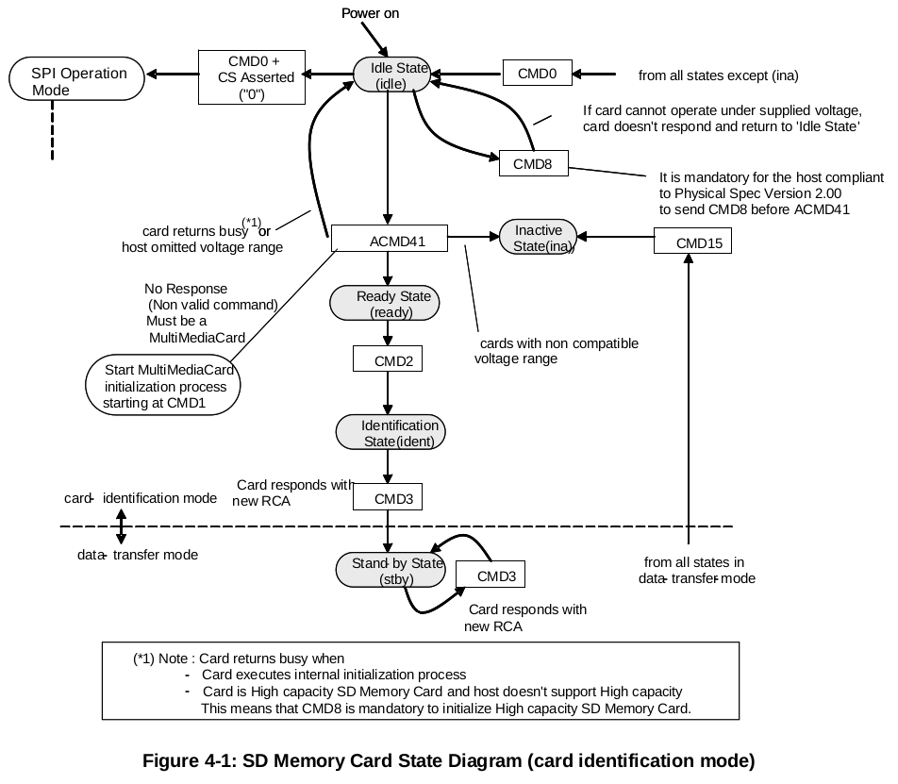

**3.3 Card Initialization and Identification**

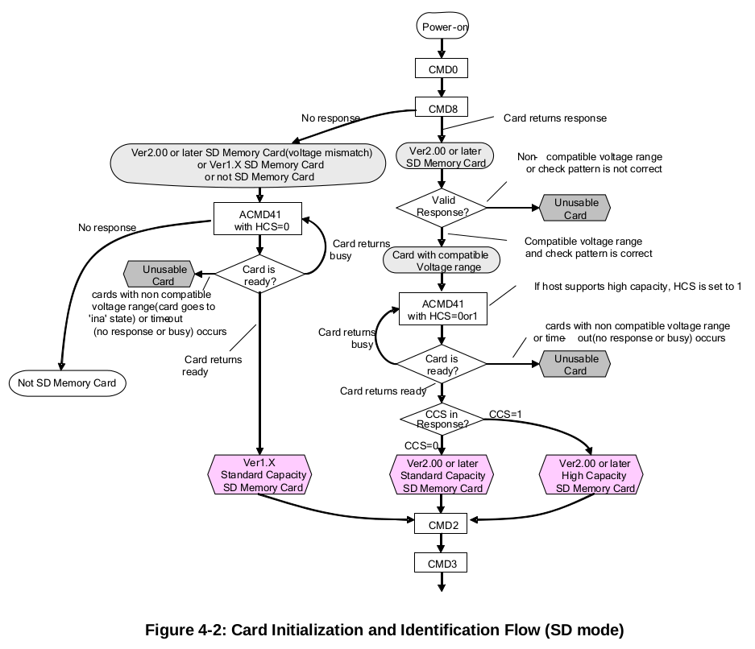The initialization process starts with SDSENDOPCOND (ACMD41) by setting its operational conditions and the HCS bit in the OCR. The HCS (Host Capacity Support) bit set to 1 indicates that the host supports High-Capacity SD Memory cards. The HCS (Host Capacity Support) bit set to 0 indicates that the host does not support Hight Capacity SD Memory cards.

**3.4 Data Transfer Mode**

Until the end of Card Identification Mode the host shall remain at fOD frequency because some cards may have operating frequency restrictions during this mode. In Data Transfer Mode the host may operate the card in fPP frequency range. The host issues SENDCSD(CMD9) to obtain the Card Specific Data (CSD register), e.g., block length, card storage capacity, etc. The broadcast command SETDSR (CMD4) configures the driver stages of all identified cards. It programs their DSR registers corresponding to the application bus layout and the number of cards on the bus and the data transfer frequency. The clock rate is also switched from fOD to fPP at that point. SETDSR command is an option for the card and the host.

CMD7 is used to select one card and put it into the Transfer State. Only one card can be in the Transfer State at a given time. If a previously selected card is in the Transfer State its connection with the host is released and it will move back to the *Stand-by State*. When CMD7 is issued with the reserved relative card address "0x0000", all cards are put back to *Stand-by State*.

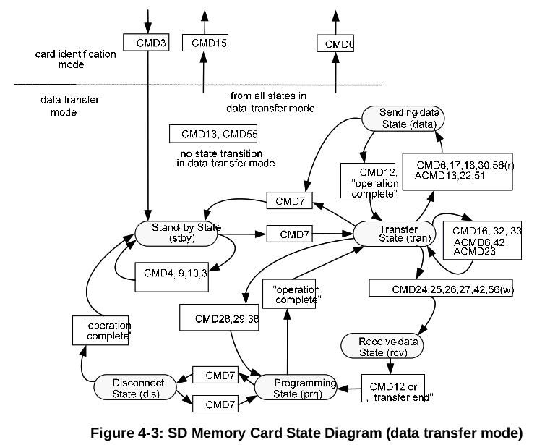

The relationship between the various data transfer modes is summarized below.

* All data read commands can be aborted any time by the stop command (CMD12). The data transfer will terminate and the card will return to the *Transfer State*. The read commands are: block read (CMD17), multiple block read (CMD18), send write protect (CMD30), send SCR (ACMD51) and general command in read mode (CMD56).
* All data write commands can be aborted any time by the stop command (CMD12). The write commands shall be stopped prior to deselecting the card by CMD7. The write commands are: block write (CMD24 and CMD25), program CSD (CMD27), lock/unlock command (CMD42) and general command in write mode (CMD56).
* As soon as the data transfer is completed, the card will exit the data write state and move either to the *Programming State* (transfer is successful) or *Transfer State* (transfer failed).
* If a block write operation is stopped and the block length and CRC of the last block are valid, the data will be programmed.
* The card may provide buffering for block write. This means that the next block can be sent to the card while the previous is being programmed. If all write buffers are full, and as long as the card is in *Programming State*, the DAT0 line will be kept low (BUSY).
* There is no buffering option for write CSD, write protection and erase. This means that while the card is busy servicing any one of these commands, no other data transfer commands will be accepted.
* DAT0 line will be kept low as long as the card is busy and in the Programming State. Actually, if the CMD and DAT0 lines of the cards are kept separated and the host keeps the busy DAT0 line disconnected from the other DAT0 lines (of the other cards), the host may access the other cards while the card is in busy.
* Parameter set commands are *not* allowed while card is programming. Parameter set commands are: set block length (CMD16), erase block start (CMD32) and erase block end (CMD33).
* Read commands are not allowed while card is programming.
* Moving another card from *Stand-by* to *Transfer State* (using CMD7) will not terminate erase and programming operations. The card will switch to the *Disconnect State* and will release the DAT line.
* A card can be reselected while in the *Disconnect State* using CMD7. In this case the card will move to the *Programming State* and reactivate the busy indication.
* Resetting a card (using CMD0 or CMD15) will terminate any pending or active programming operation. This may destroy the data contents on the card. It is the host's responsibility to prevent this.
* CMD34-37, CMD50 and CMD57 are reserved for SD command system expansion. State transitions for these commands are defined in each command system specification.

**3.5 Commands**

**3.5.1 Command Format**

All commands have a fixed code length of 48 bits, needing a transmission time of 1.92 us @ 25 MHz and 0.96 us @ 50 MHz.

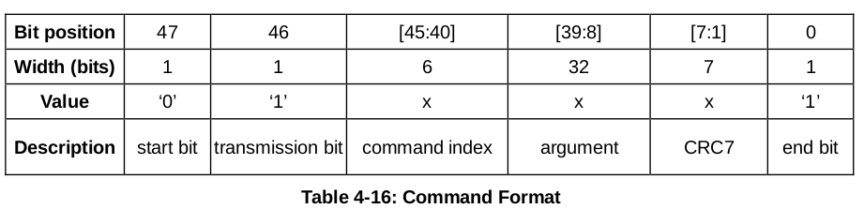

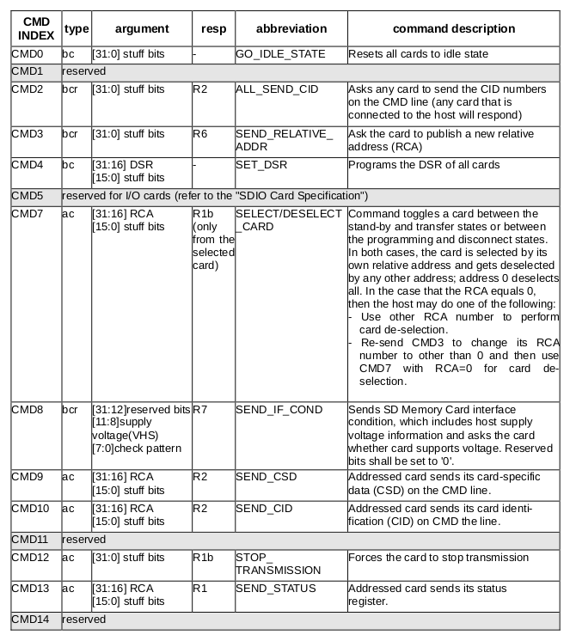**3.5.2 Detailed Command Description**

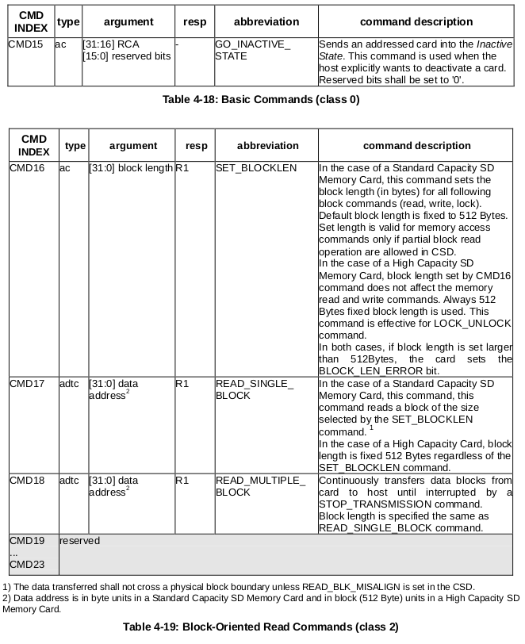

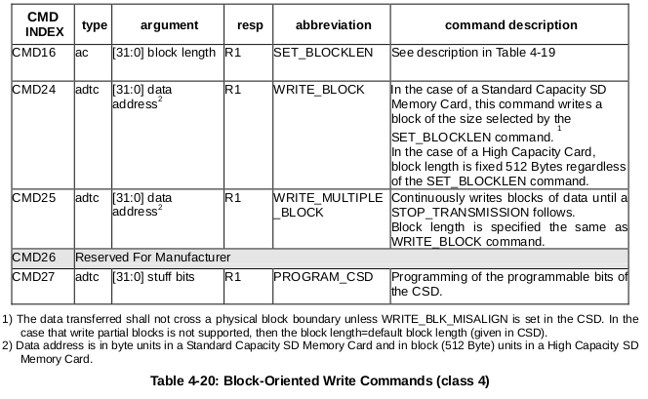

**3.6 Responses**

All responses are sent via the command line CMD. The response transmission always starts with the left bit of the bit string corresponding to the response codeword. The code length depends on the response type.

There are five types of responses for the SD Memory Card. The SDIO Card supports additional response types named R4 and R5.

**3.6.1 R1 (normal response command):**

Code length is 48 bits. The bits 45:40 indicate the index of the command to be responded to, this value being interpreted as a binary coded number (between 0 and 63). The status of the card is coded in 32 bits.

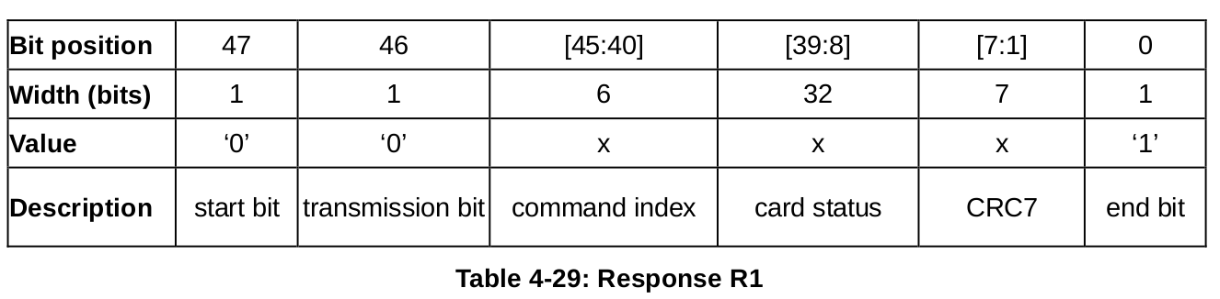

**3.6.2 R1b**

R1b is identical to R1 with an optional busy signal transmitted on the data line. The card may become busy after receiving these commands based on its state prior to the command reception. The Host shall check for busy at the response.

**3.6.3 R2 (CID, CSD register)**

Code length is 136 bits. The contents of the CID register are sent as a response to the commands CMD2 and CMD10. The contents of the CSD register are sent as a response to CMD9. Only the bits [127…1] of the CID and CSD are transferred, the reserved bit of these registers is replaced by the end bit of the response.

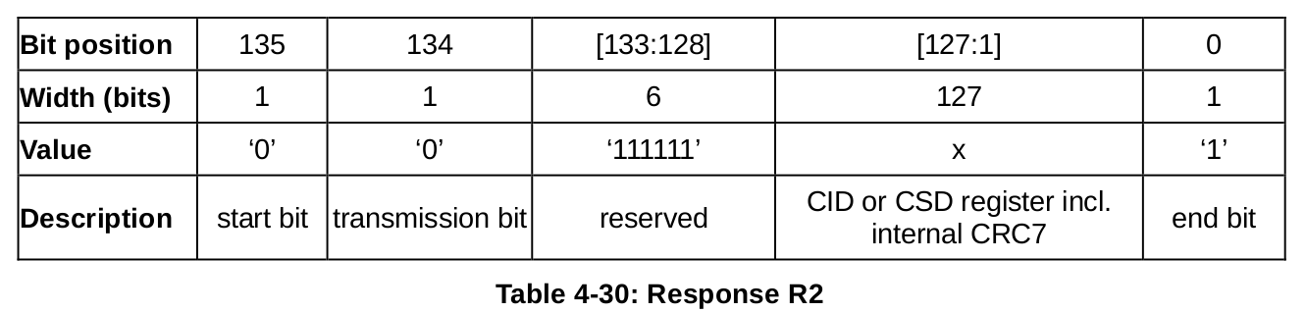

**3.6.4 R3 (OCR register)**

Code length is 48 bits. The contents of the OCR register are sent as a response to ACMD41.

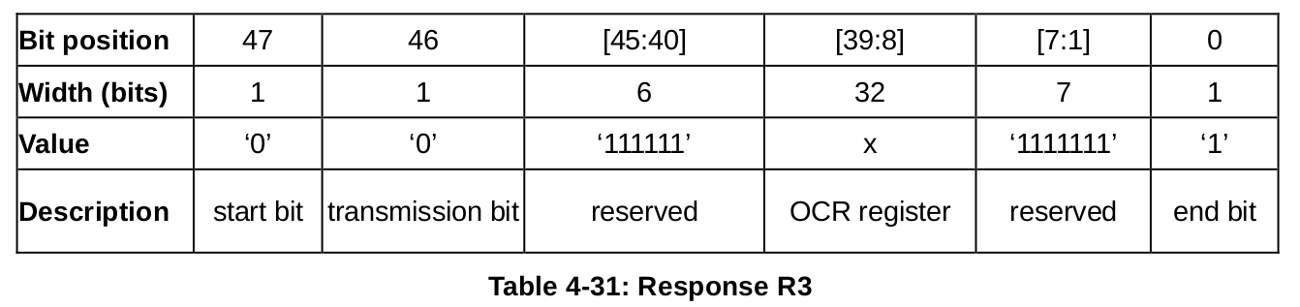

**3.6.5 R6 (Published RCA response)**

Code length is 48 bits. The bits 45:40 indicate the index of the Command to be responded to - in that case, it will be '000011'(together with bit 5 in the status bits it means = CMD3). The 16 MSB bits of the argument field are used for the Published RCA number.

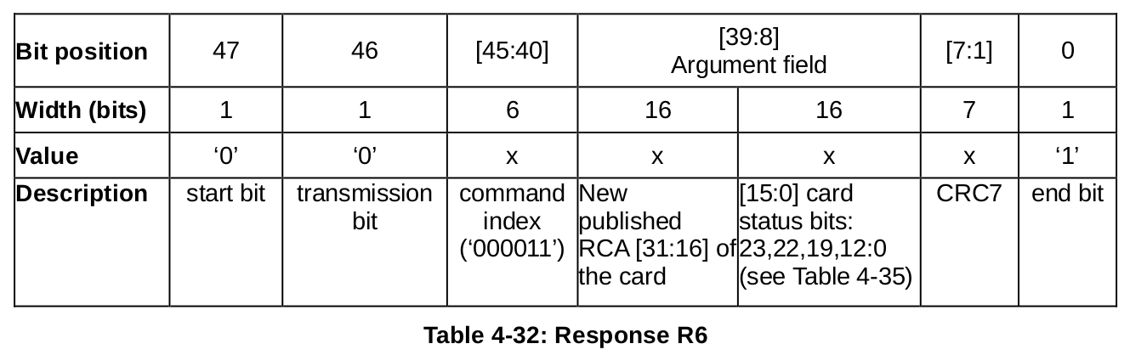

**3.7 R7 (Card Interface Condition)**

Code length is 48 bits. The card support voltage information is sent by the response of CMD8. Bits 19-16 indicate the voltage range that the card supports. The card that accepted the supplied voltage returns R7 response. In the response, the card echoes back both the voltage range and check pattern set in the argument.

